**RESUME**

Ms. Elisabeth Hial

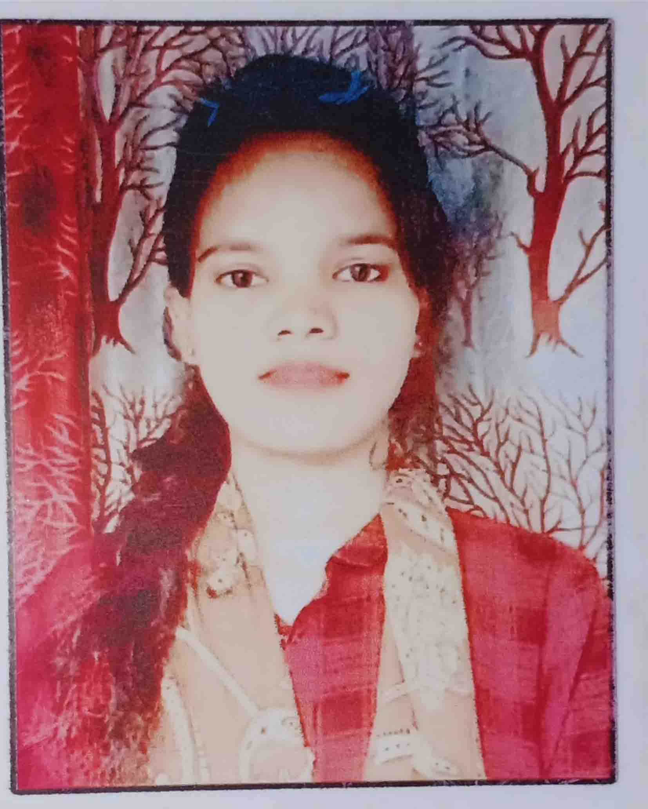

E-mail ID: sujatahial015@gmail.com

Mob: 7608042460

Educational Qualification:

* Matriculation from BSE Odisha in the Year 2013
* Arts from CHSE Odisha in the Year 2015

Computer Knowledge:

Pursuing Computer Classes

Strength:

* Always target oriented
* Strong communication skill
* Good Leadership, Hard working
* Well Thinking Capacity

Experience:

* Have Worked in Block Office Jeypore

Personal Skills:

Comprehensive problem solving abilities, willingness to learn, a good listener and has the capacity to lead a team.

#### Personal Details:

Name : Ms. Elisabeth Hial

Father’s Name : Mr. Rajendra Hial

Date of Birth : 01-07-1994

Sex : Female

Marital Status : Unmarried

Nationality : Indian

Religion : Christian

Language Known : Oriya & Hindi

Address : AT – Court Lane, Jeypore

PO – Jeypore

PS – Jeypore

DIST– Koraput

PIN - 764001

STATE – ODISHA

#### Declaration:

I do hereby declare that all the statements given above are true and correct to the best of my knowledge and belief.

Date: / / Elisabeth Hial

Place: Jeypore Signature